**DOKUMENTASI**

**API LARAVEL**

1. **Start server**

$ php artisan serve

1. **X-CSRF-TOKEN**

Get X-CSRF-TOKEN

URL: http://127.0.0.1:8000/token

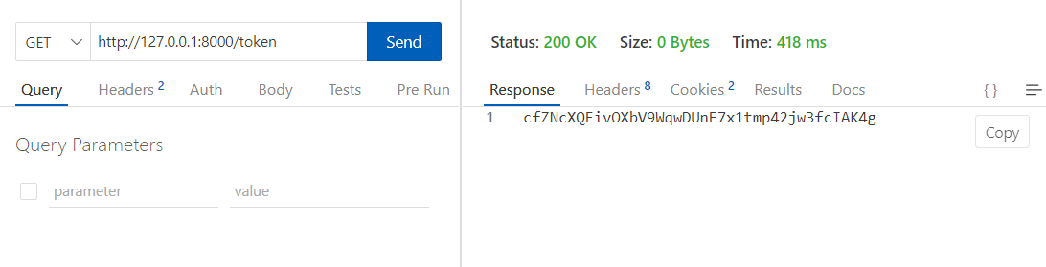

1. **JWT Auth**

Get access JWT Auth

URL: http://127.0.0.1:8000/auth

Username and Password from table users. Password is encrypted with bcrypt.

For create bcrypt password access url http://127.0.0.1:8000/api/en/[YOUR_PASSWORD]

|  |  |
| --- | --- |
| Set Header | Set Body |
|  |  |

1. **Get data**

For getting data with JWT

URL: http://127.0.0.1:8000/api/va/no_user

